Project Report Template

1. **INTRODUCTION** 
   1. Overview

Vehicle Management is an application where a customer Details are stored inorder to choose cars, bikes and commercial vehicles for travel with in the city.

* 1. Purpose

Salesforce Management System helps to streamline Cab to the routes that are generated by the admin.

1. **Problem Definitions & Design Thinking**
   1. Empathy Map

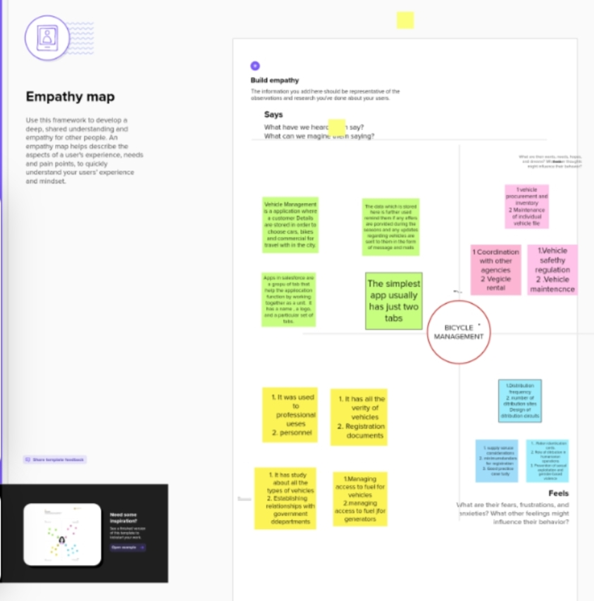

* 1. Ideation & Brainstorming Map

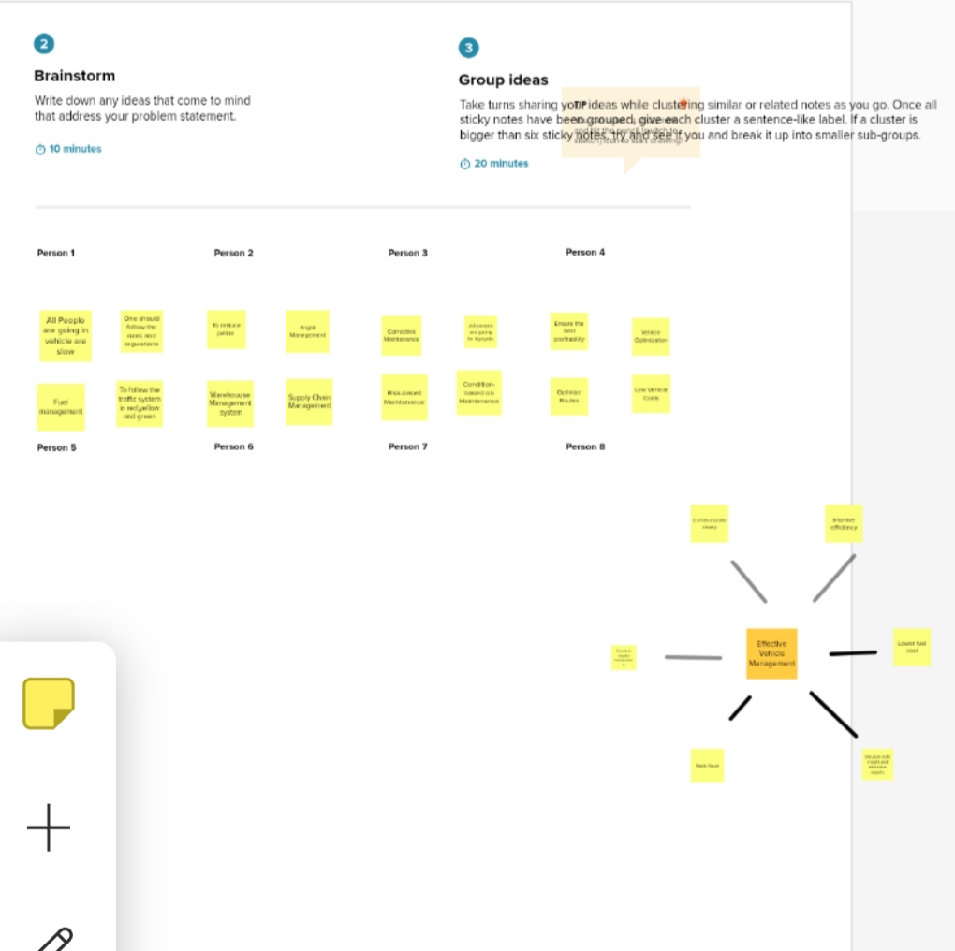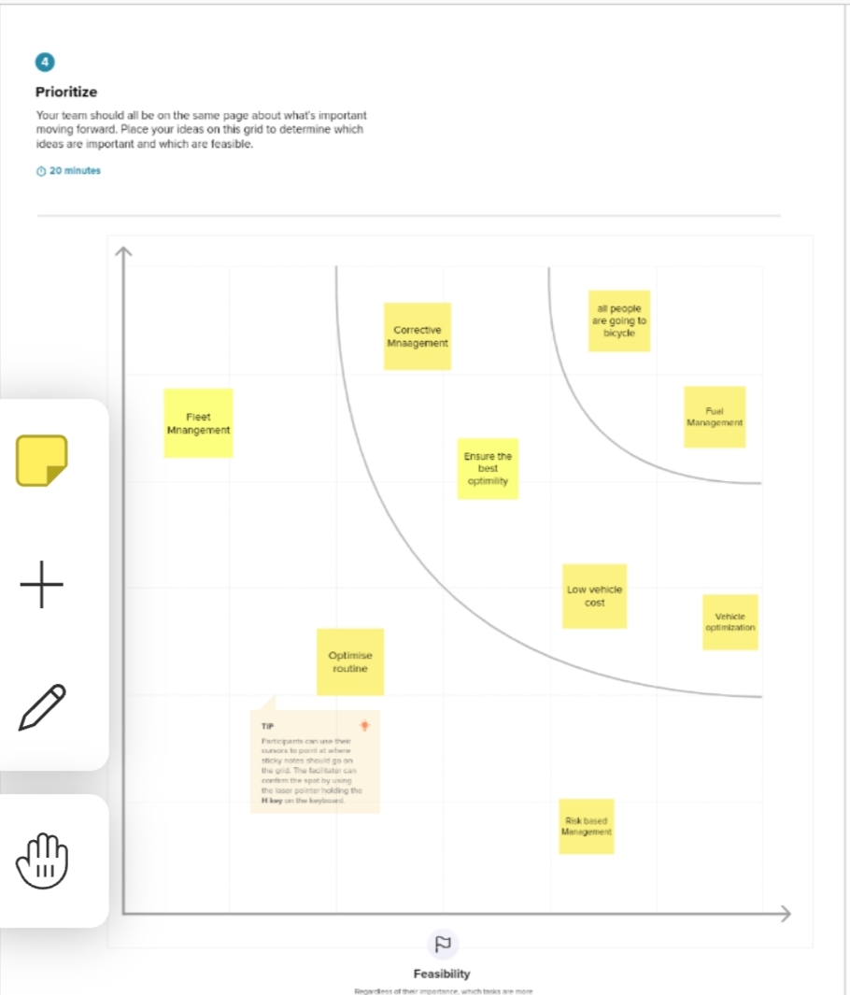

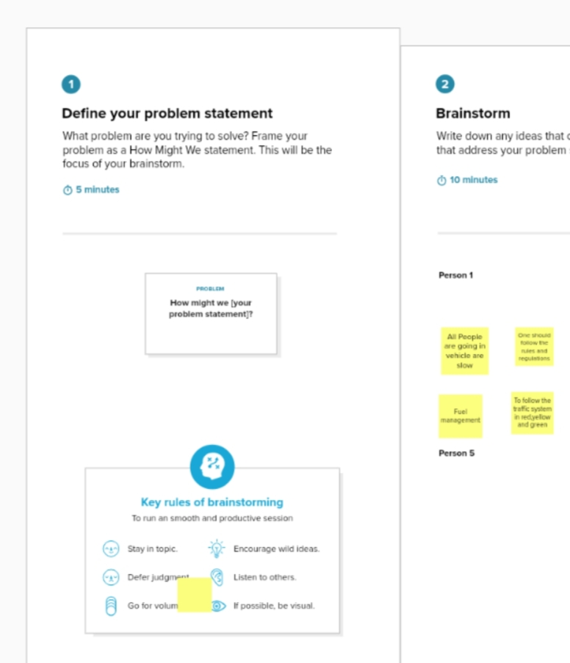

1. **Result**
   1. Y7

|  |  |
| --- | --- |
| Object Name | Fields in the Object |
| Vehicles | |  |  | | --- | --- | | Fields Names | Data Types | | Customer Name | Text | | Vehicle Type | Number | | 2WHEELERS | Picklist | | 4WHEELERS | Picklist | | Vehicle Name | Text | | Vehicle No | Text | | Classic No | Text | | Colour | Text | | Body type | Text | | Vehicle Includes | Multi Picklist | | Condition | Picklist | | Mileage | Text | | Seats | Number | | Start Date | Date/Time | | End Date | Date/Time | | Opportunity | Lookup | | Customer Mobile No | Number | |
| Driver | |  |  | | --- | --- | | Field | Data Type | | Driver Name | Text | | Licence No | Text | | Mobile No | Number | | Fair Per Hour | Text | | Vehicle | Lookup | |

3.**2 Activity & Screenshot**

To create an object:

Creation of Objects for Vehicle Management to create Vehicles object.

* Go to setup, click object manager
* Click create and select custom object

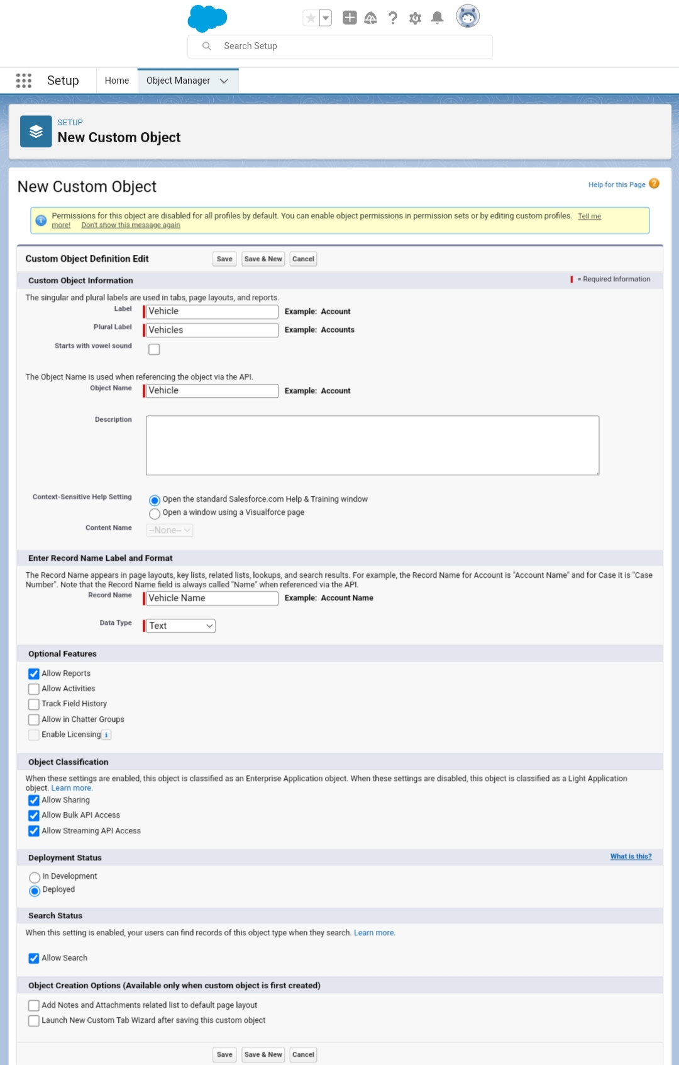

* Click save.

Similarly create Driver Object

Lets create custom field

To create field in vehicle object

* Go to setup, click object manager.
* Select vehicle object.
* Click new.

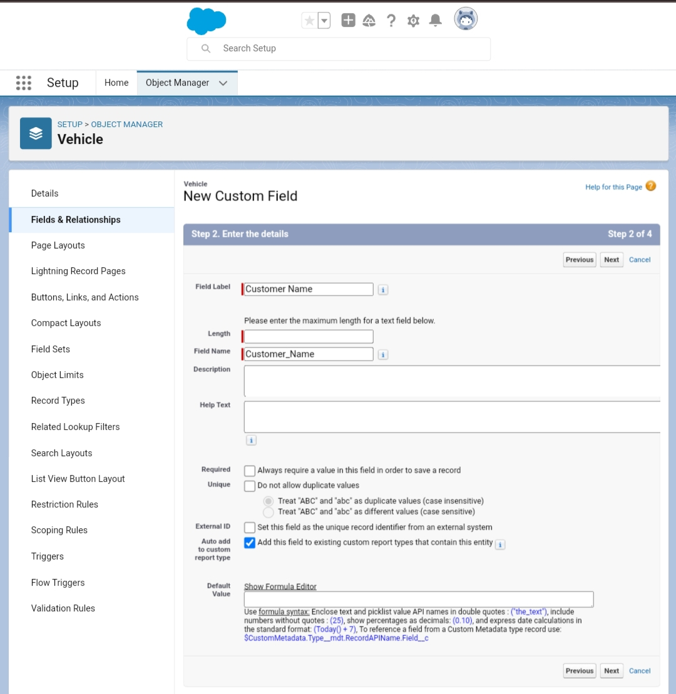

* Click save.
* Similary create all field lables and field in driver object.

**Create the Vehicle Management Construction app**

* Create vehicle management app
* Create profile and user
* Create report and go to app launcher select vehicle management app.
* Click new report.

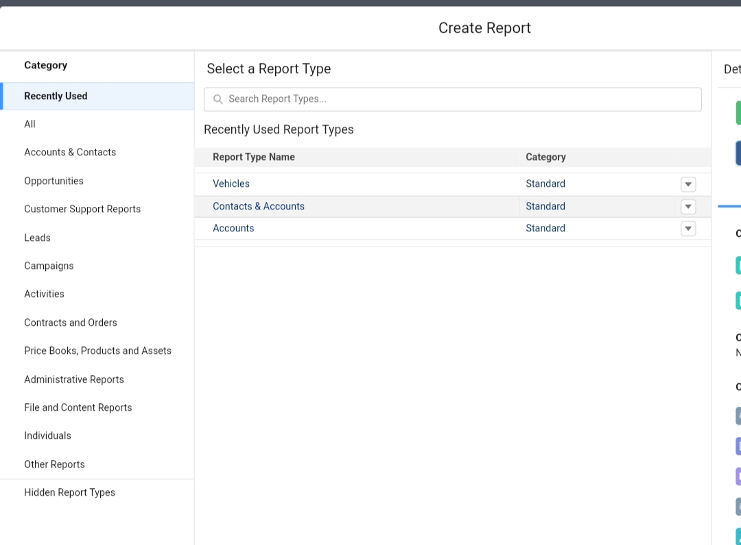

* Start repot and enter the datas.
* Then save and run.

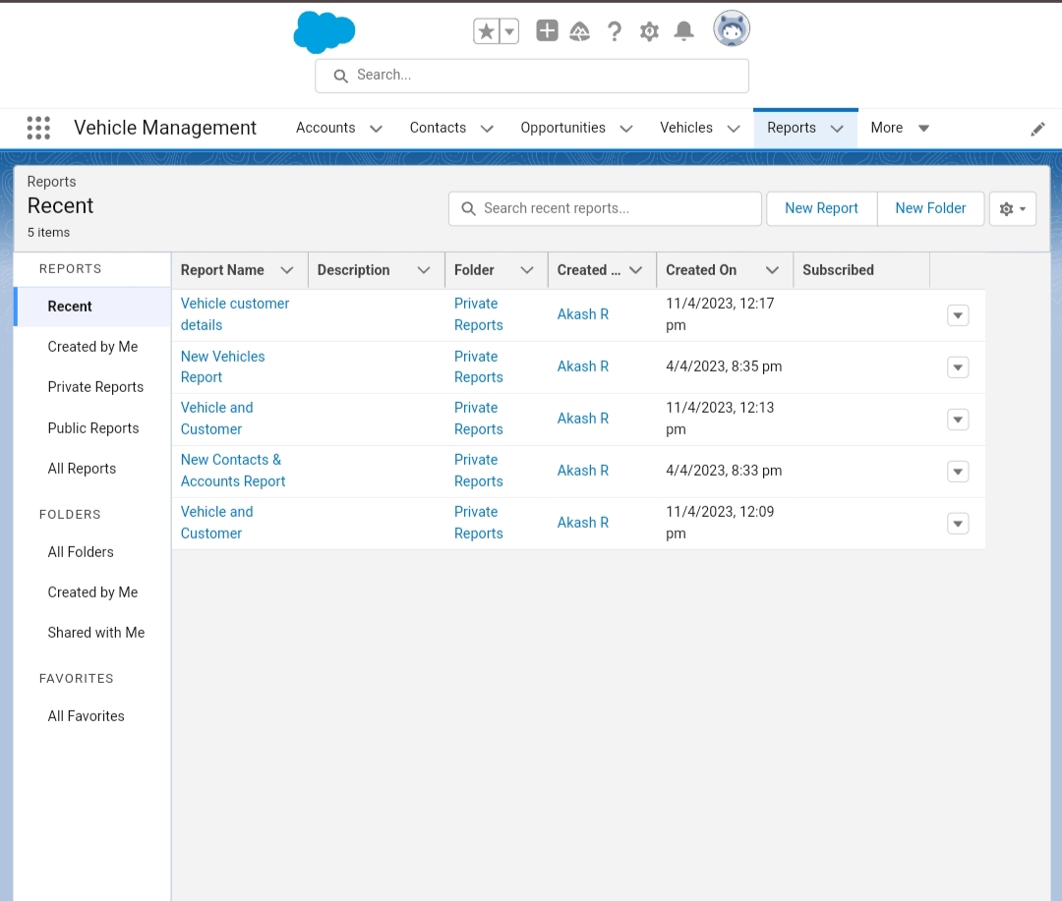

* Similarly create dashboard.

1. **Trailhead Profile Public URL**

Team Lead : [trailblazer.me/id/akasr18](http://trailblazer.me/id/akasr18)

Team Member 1 : <https://trailblazer.me/id/dineg20>

Team Member 2 : <https://trailblazer.me/id/bergb2>

**Advantages and Disadvantages**

* Improve fleet safety working conditions.
* Improve the behaviour and performance of drivers and beat unsafe driving.
* Shedule shifts and work hours.
* Manage fuel efficiency
* Active tracking bases fleet management requires monthly subscriptions charges and data usage charges.
* It requires skilled resources to maintain such system. This increases maintenance costs.
* GPS device used in fleet management is power hungry which drains battery faster.

**Applications**

* A tracking program for company vehicles.It keeps track of records of companys vehicles.
* Usage by employees who,when, for what purpose, for how long run the particular car.

**Conclusion**

* The vehicle management system proposed to makes easy process of managing vehicle with the objective to replace the current approach**.**

**Future Scope**

* In the modern age, many people have vehicles, vehicles is now basic need.Every place is under the process of urbanization.
* In case ofany damages and problem of vehicle that will claim by parking management.
* Maintain records in short time of period.
* Determines the parking area is full or not.